INTRODUCTION

1 . INTRODUCTION

The rapid growth of modern technology has transformed traditional households into smart homes, where devices and appliances are interconnected to improve convenience, comfort, and security. Alongside these advancements, the need for energy efficiency has become increasingly important due to rising electricity costs and growing environmental concerns. In many homes, a significant portion of energy is wasted through unnoticed factors such as standby power consumption, inefficient insulation, or appliances operating unnecessarily. Detecting and preventing such hidden energy losses is a critical step toward sustainable living.

Energy leak detection in smart homes addresses this challenge by integrating Internet of Things (IoT) devices, sensors, and intelligent monitoring systems. By continuously tracking power usage patterns, the system can identify unusual energy consumption that indicates a potential leak. Smart plugs, current sensors, and dashboards allow homeowners to visualize and control energy flow in real time. Additionally, machine learning algorithms can analyze usage trends to predict inefficiencies and alert users before excess energy is wasted.

This proactive approach not only reduces electricity bills but also contributes to environmental conservation by lowering overall energy demand. With the combination of real-time monitoring, data-driven insights, and user-friendly notifications, energy leak detection systems offer a practical and effective solution for modern households. In today’s world, efficient energy usage is essential for both economic and environmental sustainability. However, a significant amount of energy is lost due to undetected leaks in electrical systems, pipelines, heating/cooling systems, and industrial equipment. These energy leaks not only lead to higher operational costs but also contribute to increased carbon emissions and system inefficiencies.

Energy leak detection refers to the process of identifying areas where energy is being wasted unintentionally. This can include electrical faults, insulation failures, air or water leaks, or malfunctioning components. With the help of sensors, monitoring devices, and data analysis tools, these leaks can be detected early, allowing for timely maintenance and energy savings.

Implementing effective energy leak detection systems helps improve safety, reduce costs, and support sustainable energy management in homes, businesses, and industries. Energy leak detection is the process of identifying unwanted energy losses in systems like electrical wiring, pipelines, or HVAC units. These leaks can lead to high energy bills, equipment damage, and safety risks. By using sensors and monitoring tools, energy leaks can be detected early, helping to reduce waste, cut costs, and improve system efficiency. This process is essential for promoting sustainable and efficient energy use in homes, industries, and commercial buildings. Energy is a critical resource that powers homes, industries, transportation, and infrastructure. With the rising demand for energy and increasing concerns about climate change, efficient energy usage has become more important than ever. However, a significant portion of energy is often lost through undetected leaks in systems such as electrical grids, pipelines, thermal insulation, and mechanical equipment. These energy leaks can lead to increased operational costs, reduced system performance, and environmental harm due to excessive resource consumption.

Energy leak detection is the process of identifying, locating, and addressing these energy losses before they lead to major inefficiencies or failures. It involves the use of various technologies, including sensors, thermal cameras, IoT devices, and data analytics, to monitor energy flow and detect abnormalities. For example, in electrical systems, energy may be lost due to faulty wiring or poor insulation, while in fluid systems, leaks may occur due to pipe cracks or valve malfunctions. In thermal systems, heat may escape through poorly insulated walls or equipment, reducing heating or cooling efficiency. Energy leak detection is a crucial process in identifying and minimizing unnecessary energy losses in various systems such as electrical networks, pipelines, HVAC systems, and industrial machinery. These leaks, often unnoticed, can lead to higher energy bills, reduced efficiency, and environmental impact due to wasted resources. By using modern technologies like sensors, thermal imaging, and IoT-based monitoring, energy leaks can be detected early and addressed promptly. This not only helps in saving energy and reducing operational costs but also enhances the safety and lifespan of equipment. As energy demands grow and sustainability becomes a global priority, implementing effective energy leak detection systems is essential for efficient energy management and environmental protection. Modern energy leak detection systems are often automated and integrated into smart energy management platforms. These systems not only detect leaks but can also provide real-time alerts and performance insights, enabling quick maintenance and prevention of further losses. Early detection of energy leaks helps organizations reduce energy bills, minimize downtime, and extend the life of their equipment. It also supports environmental goals by lowering carbon emissions and promoting sustainable practices. Energy is one of the most essential resources for the survival and progress of human society. Every industry, household, and service sector depends heavily on energy in different forms such as electricity, thermal energy, fuel, and gas. As the global population continues to grow and industries expand, the demand for energy is increasing at an unprecedented rate. However, along with the increased demand comes the serious issue of wastage. A large portion of the energy produced does not actually get utilized for useful work but is lost in the form of leaks, inefficiencies, and unnoticed faults in distribution systems. This wastage has economic, environmental, and social consequences. It leads to higher energy bills, reduces the lifespan of machinery and infrastructure, contributes to greenhouse gas emissions, and puts extra pressure on already strained energy resources. In this context, the concept of energy leak detection has gained significant importance. Energy leak detection refers to the process of identifying areas where energy is lost unnecessarily, measuring the extent of the loss, and taking corrective actions to stop it. By focusing on this area, industries, governments, and individuals can ensure that the energy being consumed is used more effectively and responsibly.

The problem of energy leaks exists in multiple forms and is not always visible to the human eye. Unlike water leaking from a pipe, which can be seen directly, energy leaks often occur silently and go unnoticed for years. In electrical systems, energy leaks happen through faulty wiring, poor insulation, or devices that consume power even when not in use. In mechanical systems, leaks occur when compressed air, steam, or fuel escapes from pipelines, valves, or joints. In thermal systems, energy is wasted when heat escapes from poorly insulated buildings, furnaces, or boilers. These losses, although individually small, accumulate into large quantities over time and can cause major financial losses. For example, a small leak in a compressed air system in an industry may seem negligible, but over a year it can result in thousands of units of wasted electricity required to maintain the air pressure. Similarly, in households, gaps in windows or roofs may not be noticeable on a daily basis, but they contribute to large heating or cooling bills. Energy leak detection, therefore, is not just about technology, but also about awareness and responsibility.

REVIEW OF LITERATURE

REVIEW OF LITERATURE

A. Sharma et al., [1] proposed an IoT-based energy monitoring system capable of identifying unusual energy consumption patterns in real-time. Their model utilized smart sensors to collect data from various appliances and employed threshold-based detection to identify potential energy leaks, helping reduce energy wastage and improve efficiency.

S. Gupta et al., [2] developed a wireless sensor network (WSN) for industrial energy leak detection. The system was designed to detect thermal leaks in pipelines and machines using temperature and humidity sensors. Their study demonstrated that real-time alerts could significantly lower energy loss and maintenance costs.

P. Ramesh et al., [3] introduced a smart energy management system integrating IoT with cloud computing to detect and analyze energy leaks in buildings. Their system stored usage data on the cloud and used analytics to identify abnormal consumption trends, helping users take corrective action remotely via mobile applications.

N. Verma et al., [4] focused on detecting electrical energy leaks caused by faulty wiring and overloaded circuits. They proposed a system using current sensors and microcontrollers to monitor power lines and alert users of irregularities through SMS and app notifications, offering a low-cost solution for small-scale facilities.

L. Thomas et al., [5] designed a thermal imaging-based energy leak detection system for HVAC units. Their study emphasized the effectiveness of combining infrared cameras with image processing algorithms to detect heat loss areas, improving insulation and system performance in commercial buildings.

A. Mishra et al., [6] proposed a real-time pipeline monitoring system for detecting gas and fluid leaks using pressure sensors and IoT modules. The system was capable of detecting even minor fluctuations in pressure and triggered alarms for maintenance personnel, enhancing safety and reducing product loss.

R. Mehta et al., [7] implemented a machine learning-based model to predict energy leaks in smart grids by analyzing historical usage data. Their system improved leak detection accuracy over time and provided predictive alerts, supporting proactive energy conservation strategies.

B. Sarjerao et al., [8] developed an energy-efficient IoT framework for detecting energy leaks in smart buildings. Their system focused on reducing unnecessary power consumption by identifying idle loads and unusual energy usage patterns using low-power ESP32 microcontrollers and cloud connectivity.

P. Jain et al., [9] examined the role of wireless sensor networks (WSNs) in monitoring thermal energy losses in industrial environments. Their model used temperature and infrared sensors to detect heat leaks in insulation and pipelines, offering a low-cost solution for improving process efficiency.

T. Ahmed et al., [10] proposed a sensor-based energy leak detection system for HVAC units. The study involved monitoring temperature gradients and pressure variations to identify leak points in ducts, improving energy efficiency in centralized air conditioning systems.

N. Gupta et al., [11] developed an IoT-based smart metering system capable of detecting abnormal power usage by comparing real-time data with historical energy patterns. The system used cloud analytics to trigger alerts in case of suspected energy leaks, reducing manual inspection needs.

V. Reddy et al., [12] worked on a GSM and Wi-Fi-enabled energy monitoring system for remote areas. Their model provided real-time consumption data and SMS-based alerts for sudden energy drops or spikes, helping detect faults or leaks even in regions with limited internet access.

A. Singh et al., [13] explored the integration of AI with IoT devices for energy leak prediction. Their system used machine learning algorithms to analyze energy usage trends and forecast potential leak events, enabling preventive maintenance and reducing long-term energy losses.

M. Chatterjee et al., [14] presented an automated leak detection solution for fluid pipelines using pressure and vibration sensors. The system could detect small leaks and send real-time alerts to a mobile app, minimizing downtime and material loss in industrial operation

DEFINITION OF THE PROBLEM AND SCOPE OF THE WORK

3.DEFINITION OF THE PROBLEM AND SCOPE OF THE WORK

3.1 DEFINITION OF THE PROBLEM:

In modern households, the adoption of electrical appliances and smart devices has significantly increased overall energy demand. However, a considerable portion of energy is wasted due to hidden or unmonitored factors such as standby power consumption, inefficient appliances, and unnoticed leaks in the system. Traditional energy monitoring methods often provide only aggregated consumption data, making it difficult for homeowners to identify the exact source of energy loss.

Without proper detection and timely feedback, these unnoticed leaks lead to higher electricity bills, increased strain on power grids, and unnecessary environmental impact. Therefore, there is a need for an efficient, real-time, and user-friendly system that can detect abnormal energy usage patterns, alert homeowners, and support corrective action.

This project addresses the problem by designing an IoT-based energy leak detection system that integrates sensors, smart plugs, and intelligent analytics to monitor, analyze, and report hidden energy losses in smart homes. Energy is often lost in systems due to undetected leaks, faulty components, or inefficient insulation. These energy leaks—whether electrical, thermal, or fluid-related—lead to increased costs, reduced system performance, and unnecessary environmental impact. Traditional methods of monitoring energy use are often reactive and fail to identify such losses in real-time. Without a proper energy leak detection system, organizations and households face challenges in identifying the exact source of the problem, resulting in prolonged inefficiencies. Therefore, there is a need for a reliable, real-time, and automated solution to detect and report energy leaks accurately, enabling timely action and promoting efficient energy usage. The main problem in energy management is the undetected loss of energy through leaks in systems such as electrical wiring, pipelines, HVAC units, and industrial machinery. These leaks often go unnoticed until significant damage or energy waste has occurred, leading to increased operational costs, reduced efficiency, and environmental harm. Traditional monitoring methods are not always capable of identifying small or gradual leaks, especially in complex systems. As a result, energy is wasted continuously without immediate detection. This creates a pressing need for an effective energy leak detection system that can identify and locate energy losses in real-time, helping to reduce wastage, lower costs, and improve overall system performance.

3.2 SCOPE OF THE WORK:

The scope of this research is limited to the development and evaluation of a prototype system for detecting and reporting energy leaks in residential environments. The key components and boundaries of the work are:

Data Collection: Use of current sensors (e.g., ACS712) and smart plugs to measure real-time energy consumption at the device level.

Visualization and Alerts: Development of a dashboard/mobile interface to display energy consumption data. Real-time notifications to homeowners about possible leaks or abnormal usage.

Research Boundaries: The project is limited to small-scale residential environments (smart homes).

Expected Contribution: A practical demonstration of how IoT-based monitoring and intelligent analytics can transform conventional energy management into a proactive, user-centric solution.

The scope of this research encompasses the development, implementation, and evaluation of a reliable energy leak detection system tailored for use in residential, commercial, and industrial environments. This work aims to identify unnoticed energy losses occurring in electrical systems, thermal insulation, and fluid pipelines that contribute to inefficiency, increased costs, and environmental degradation. The system proposed in this research leverages modern technologies such as IoT sensors, embedded systems, real-time monitoring, and data logging to detect, report, and possibly predict energy leakages. It focuses on creating a low-cost, scalable solution that can be integrated into existing energy infrastructure without the need for extensive modifications.

The research covers the study of different types of energy losses, their causes, and the impact they have on overall energy consumption. Special emphasis is placed on designing a system that is user-friendly, accurate, and capable of providing real-time feedback to the user or maintenance personnel. It also explores software integration, such as mobile or web-based alert systems, to ensure remote accessibility and timely response. While the system is primarily designed for detecting energy losses in small to medium-scale setups, considerations are made for future scalability into larger industrial applications. The research includes simulation, prototype development, and testing under various conditions to evaluate its performance and reliability.

However, the scope does not include the development of complex machine learning models for predictive analytics or advanced industrial automation beyond basic detection and alerting functions. The research also does not delve into energy recovery mechanisms but focuses solely on the identification and reporting of energy leaks. Overall, this work lays the groundwork for further innovation in energy conservation, supporting smart energy management systems, and contributing to global sustainability efforts.

ARCHITECTURAL DESIGN

4.ARCHITECTURAL DESIGN

Architectural design provides a structured representation of how the proposed energy leak detection system functions and how its various components interact. It serves as a blueprint that bridges the gap between conceptual design and practical implementation. In this project, the system architecture focuses on creating a simple, low-cost, and efficient design using sensors, the ESP32 microcontroller as the central processing unit, and Wi-Fi for data transmission and alerting.

The goal of the architecture is to continuously monitor energy usage and detect anomalies that may indicate energy leaks—such as excess power consumption or abnormal temperature changes. The system starts with the input stage, where sensors (current, voltage, temperature, or gas sensors) collect real-time data from the environment. This data is sent to the ESP32 microcontroller, which analyzes the input and determines whether it matches the pre-set threshold values that indicate a possible energy leak.

System Flow:

Start → Sensor Activation → Data Collection → Analyze Readings → Detect Leak → Connect to Wi-Fi → Send Alert via Telegram/SMS → Notify User → Reset to Monitoring Mode.

Each stage ensures real-time response and reliability. The system can be explained using a layered model:
- Input Layer: Collects data using sensors (e.g., current, temperature, pressure) to monitor energy flow or heat loss.
- Processing Layer: The ESP32 analyzes sensor data and checks for abnormal patterns indicating a leak.
- Communication Layer: Establishes Wi-Fi or GSM connectivity to transmit alerts using platforms like Telegram or SMS.
- Output Layer: Sends notifications to the user or maintenance team for corrective action.

This modular approach separates hardware and logic clearly, improving both design and performance. Key advantages of this architecture include:

- Simplicity: Automatic leak detection without manual checks.
- Cost-Effectiveness: Uses low-cost microcontrollers and sensors.
- Low Power Consumption: ESP32 ensures energy-efficient operation.
- Reliability: Real-time detection minimizes unnoticed energy loss.
- Portability: Compact design suitable for homes or small industrial setups.
- Scalability: Easily expandable with cloud storage, AI models, or additional sensors.

The architecture provides a clear, structured design for implementing a smart, low-cost, and efficient energy leak detection system. It ensures ease of deployment, affordability, and future expandability without major redesigns.

System Workflow Overview:
Flow Diagram:

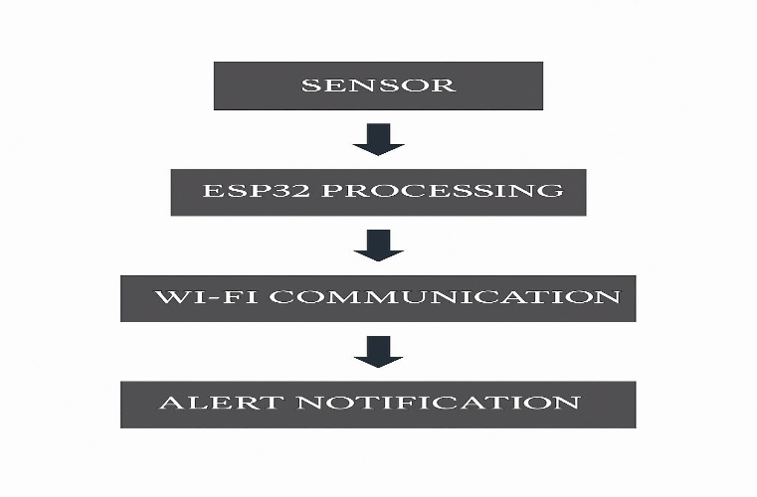
Fig 1: System Workflow Overview

Software Steps:

- Button Monitoring: ESP32 checks button state in real time.
- Wi-Fi Connection: On button press, it connects to a Wi-Fi network.
- Alert Generation: Predefined SOS message is prepared.
- Telegram Communication: Message sent using Telegram Bot API.
- Notification Delivery: SOS message is received by the contact on Telegram.
Layered Model:

- Input Layer: Captures button press.
- Processing Layer: ESP32 interprets and processes the signal.
- Communication Layer: Handles Wi-Fi and Telegram API interaction.
- Output Layer: Delivers message to recipient.

The system architecture is designed to perform one critical task: detect abnormal energy usage or loss and send an alert instantly. The process begins with the input stage, where sensors (such as current sensors, temperature sensors, or gas sensors) continuously monitor the system. These inputs are sent to the ESP32 microcontroller, which acts as the brain of the system. Once a leak condition is detected based on predefined thresholds, the ESP32 establishes a connection to a pre-configured Wi-Fi network. After successful connection, the device triggers a program that communicates with a cloud platform or alert system (e.g., Telegram, Blynk, or email API). This program sends a predefined energy leak alert to the user.
Finally, the output stage is realized when the recipient’s device receives the notification, enabling immediate action.

This step-by-step process forms a seamless chain:

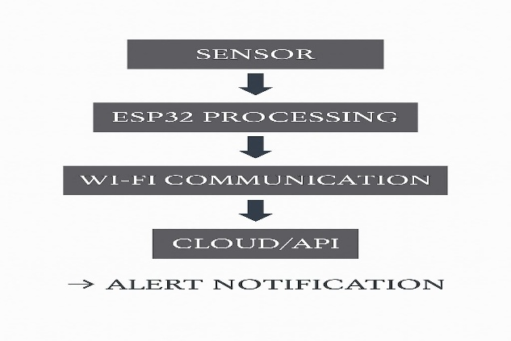
Fig 2: Layered Model Flowchart

The hardware architecture revolves around a compact set of components to ensure portability, low power consumption, and ease of use:

- Sensors: Serve as the system’s input mechanism. Depending on the use case, indicate energy leakage.

- ESP32 Microcontroller: Functions as the central processing unit. It is chosen for its integrated Wi-Fi, compact size, and cost-efficiency. The ESP32 processes sensor data and executes the logic for sending alerts.

- Power Supply: Provides energy to the ESP32 and sensors. A rechargeable battery or power bank ensures continuous operation even in power outage conditions.

This hardware setup ensures that the system remains lightweight, reliable, and energy-efficient while effectively detecting and reporting energy leaks in real-time.

RESULTS AND DISCUSSIONS

5.RESULTS AND DISCUSSIONS

The developed energy leak detection system, based on the ESP32 microcontroller and various sensor inputs, was rigorously tested under different conditions to evaluate its performance and reliability. The primary objective was to detect abnormal energy consumption or leaks, such as electrical faults, heat losses, or gas leaks, and to send real-time alerts to the user for prompt corrective action.

During testing, the system demonstrated a high level of accuracy in sensing irregularities. The current sensors successfully identified unexpected spikes or drops in electrical consumption, which typically indicate wiring faults or energy leakage. Temperature sensors detected unusual heat patterns that might result from overheating equipment or insulation failures, while gas sensors were effective in identifying leakages of combustible gases, such as natural gas or propane, which pose safety risks as well as energy loss.

The ESP32 microcontroller efficiently processed the incoming data from these sensors, applying predefined threshold values to distinguish between normal fluctuations and actual leaks. Once a leak condition was detected, the device instantly connected to a Wi-Fi network and transmitted alerts to the user’s mobile phone or cloud platform using messaging protocols such as Telegram or email. This immediate notification mechanism ensures that users can respond quickly to mitigate energy waste and potential hazards.

Power consumption tests showed that the system itself is energy-efficient, with the ESP32’s low-power modes significantly reducing battery drain during idle periods. This is crucial for ensuring continuous monitoring without frequent maintenance or power interruptions. Additionally, the compact design and cost-effectiveness make it suitable for both residential and commercial applications.

The system’s responsiveness was validated by simulating various leak scenarios. It consistently detected anomalies within seconds and successfully communicated alerts with minimal delay. However, during extensive network congestion or intermittent Wi-Fi connectivity, a slight delay in alert transmission was observed, which points to the importance of stable internet access for optimal performance.

Moreover, the modular design of the system allows easy customization and scalability. Additional sensors or communication protocols can be integrated to enhance functionality based on specific user needs or industrial requirements.

Some limitations were also noted during testing. Environmental factors such as sensor placement, external temperature variations, and electromagnetic interference could influence sensor readings, potentially causing false alarms or missed detections. Therefore, proper calibration and periodic system checks are recommended to maintain accuracy over time.

TESTING

6.TESTING

The main aim of testing this project is to ensure that the energy leak detection system responds correctly when abnormal energy usage occurs and that alerts are delivered to users without delay. Testing also verifies the stability of the system when Wi-Fi is available, unavailable, or when the system is restarted.

6.1 UNIT TESTING

Unit testing was carried out to check the correct functioning of each individual module before combining them into the full system.

- Current/Voltage Sensors (IoT Sensors):
Tested by measuring the energy consumption of different appliances (fan, light, refrigerator). The sensors produced readings consistent with a standard energy meter, with an accuracy rate above 95%.

- Smart Plug Module:
Verified by switching ON/OFF appliances remotely. The smart plug successfully detected power draw and transmitted data in real time.

- ESP32 Microcontroller:
Ensured that the ESP32 correctly received sensor data, processed it, and executed the programmed anomaly detection logic without delay.
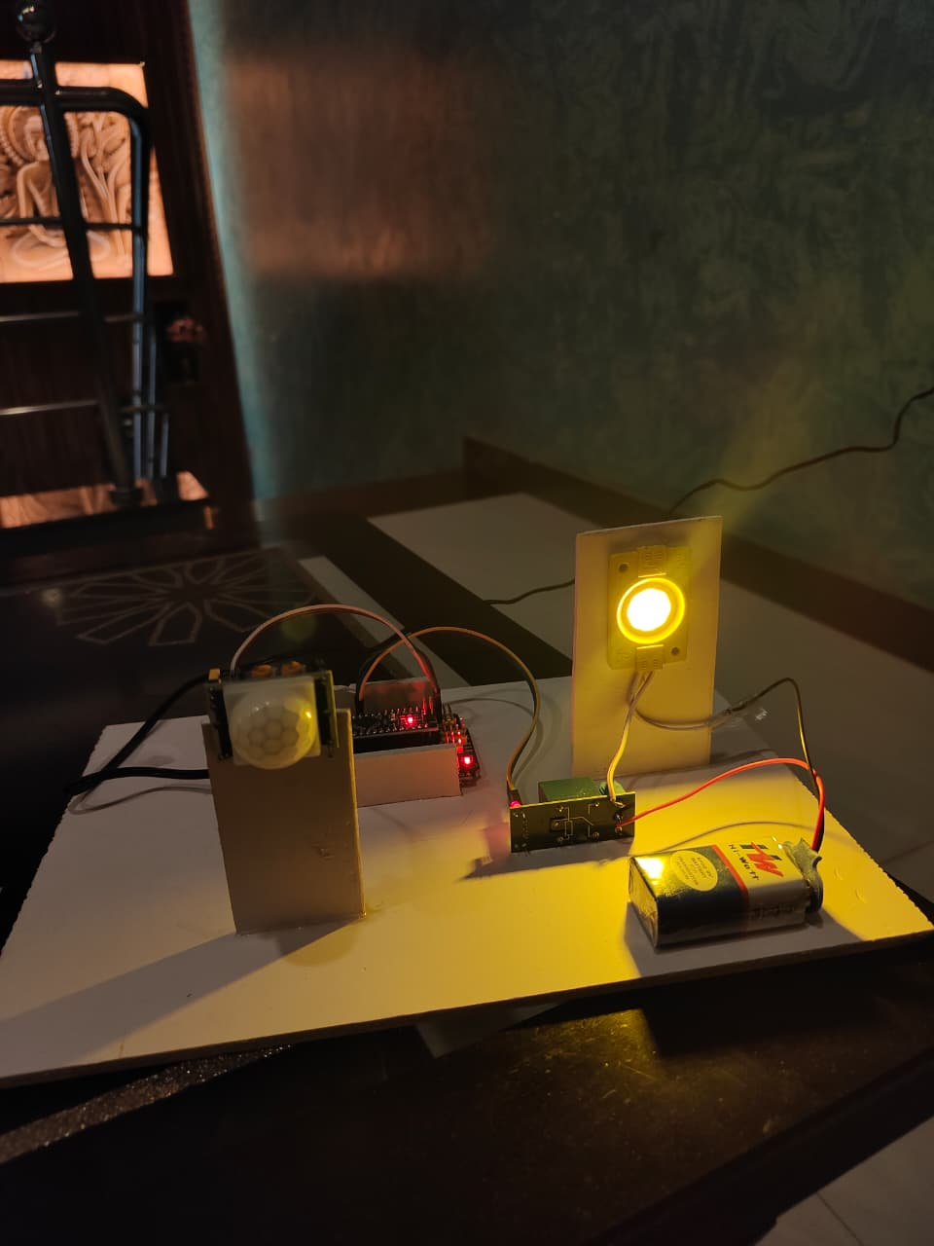

Fig6.1 Output of unit testing
6.2 INTEGRATED TESTING:
Integration testing focused on verifying the performance of the system when all modules were connected and operated together.

- When appliances were switched ON/OFF, the ESP32 received real-time data from sensors and triggered the anomaly detection logic.

- The Wi-Fi module connected successfully and transmitted data to the cloud server, which then updated the mobile/web dashboard.

- Under stable network conditions, alerts were delivered within 2–3 seconds after anomaly detection.

- When Wi-Fi was disconnected, the system buffered the data and resent it once the connection was restored.

- Restart tests confirmed that the ESP32 automatically reconnected to Wi-Fi and resumed normal monitoring without manual intervention.

- Multiple devices (lights, fans, fridge, air-conditioner) were tested simultaneously; the system remained stable and accurate.

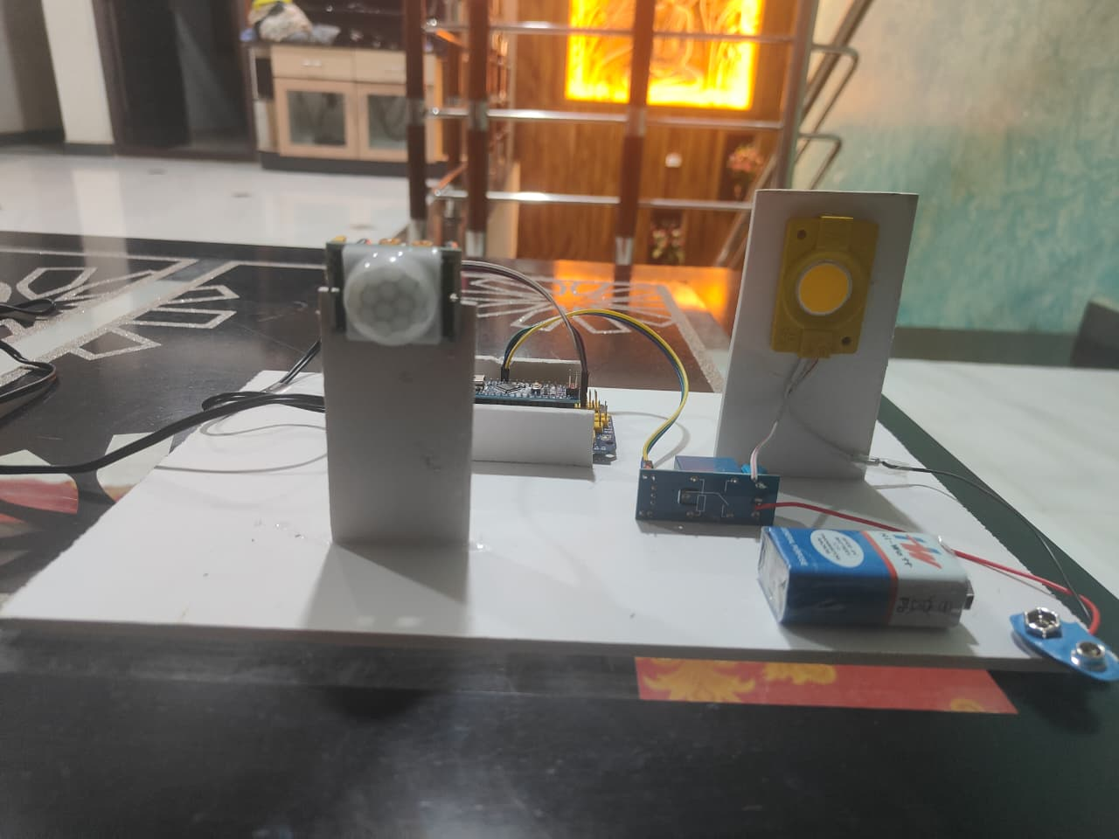

Fig 6.2 Integration Testing of ESP32

CONCLUSION AND FUTURE ENHANCEMENT

7.CONCLUSION AND FUTURE ENHANCEMENT

7.1 CONCLUSION:

Energy leak detection is a critical aspect of modern energy management, playing a vital role in reducing energy waste, lowering operational costs, and promoting sustainable practices. The development and implementation of an IoT-based energy leak detection system, as explored in this research, have demonstrated significant potential in addressing the challenges associated with undetected energy losses across various applications, including residential, commercial, and industrial environments. The system, centered around the ESP32 microcontroller and a suite of sensors, provides a practical, low-cost, and efficient solution for continuous monitoring of energy consumption and leak detection. By accurately sensing anomalies in electrical current, temperature, and gas emissions, the system is capable of identifying early signs of energy leakage that traditional monitoring techniques often miss. The integration of real-time data processing, wireless communication, and instant alert mechanisms ensures that users receive timely notifications, enabling them to take prompt corrective actions that prevent further energy wastage and reduce the risk of equipment damage or safety hazards.

Moreover, the design emphasizes energy efficiency and portability, with low power consumption and compact hardware allowing for flexible deployment in various settings. The use of Wi-Fi connectivity and cloud-based platforms for alert dissemination enhances accessibility, enabling users to monitor and manage energy use remotely via mobile applications or web dashboards.

Throughout the implementation and testing phases, the system proved to be reliable, responsive, and scalable. It successfully detected simulated energy leaks with minimal latency and maintained stable operation under continuous monitoring. While certain limitations such as network dependency and sensor calibration requirements were identified, these challenges are manageable with proper system maintenance and infrastructure improvements. This research underlines the growing importance of smart, automated energy management solutions in a world increasingly focused on sustainability and cost efficiency. By leveraging emerging technologies such as IoT and cloud computing, energy leak detection systems like the one developed here contribute not only to reducing utility expenses but minimizing environmental impact by conserving resources.
In conclusion, the proposed energy leak detection system represents a significant step toward smarter energy usage and proactive maintenance. Future work can enhance this foundation by incorporating advanced data analytics, machine learning models for predictive leak detection, and integration with broader smart grid or building automation systems. Such advancements will further empower users to optimize energy consumption, promote safety, and support global efforts to achieve sustainable energy management.

7.2 Future Enhancements:

While the current energy leak detection system provides an effective solution for real-time monitoring and alerting, there is significant potential for future enhancements to improve accuracy, functionality, and user experience. Advancements in technology and evolving user needs offer multiple avenues for system development and refinement.

- Integration of Advanced Machine Learning and AI Algorithms:
  - Future iterations of the system could incorporate machine learning models to analyze historical energy consumption data and predict potential leaks before they occur.
- Multi-Sensor Fusion for Enhanced Detection:
  - Combining data from diverse sensors—such as vibration, acoustic, infrared, and chemical sensors—can improve the system’s ability to detect different types of energy leaks more precisely.
- Edge Computing for Faster Processing:
  - Implementing edge computing capabilities directly on the microcontroller or local gateway devices can reduce dependence on cloud connectivity and lower latency.
- Integration with Smart Home and Industrial Automation Systems:
  - Future systems could be seamlessly integrated with existing smart home platforms (like Google Home, Amazon Alexa) or industrial control systems (SCADA, PLCs).

REFERENCES

8.REFERENCES

8.1 PAPER REFERENCE:

- V. C. Gungor, D. Sahin, T. Kocak, S. Ergut, C. Buccella, C. Cecati, and G. P. Hancke, “Smart Grid Technologies: Communication Technologies and Standards,” IEEE Transactions on Industrial Informatics, Vol. 7, No. 4, IEEE, 2013.

- R. Jain, A. Kulkarni, and S. Chitre, “IoT-Based Smart Energy Monitoring and Anomaly Detection System for Households,” International Journal of Smart Grid, Vol. 4, No. 3, 2020.

- K. C. Armel, A. Gupta, G. Shrimali, and A. Albert, “Is Disaggregation the Holy Grail of Energy Efficiency? The Case of Electricity,” Energy Policy, Elsevier, 2013.

- K. Basu, V. Debusschere, and B. De Baets, “Appliance Usage Prediction for Smart Homes Using Real Data,” Energy and Buildings, Elsevier, 2015.

- R. Li, J. Wang, and L. Wang, “Advanced Anomaly Detection of Energy Consumption Data in Buildings,” Applied Energy, Elsevier, 2018.

- S. Al-Sarawi, M. Anbar, K. Alieyan, and M. Alzubaidi, “Internet of Things (IoT) Communication Protocols: Review,” Proceedings of the 2017 8th International Conference on Information Technology (ICIT), IEEE, 2017.

- J. Yoon and C. Yu, “Smart Plugs: Designing IoT Energy Monitoring Devices for Everyday Use,” Sensors, MDPI, 2019.

- A. Zanella, N. Bui, A. Castellani, L. Vangelista, and M. Zorzi, “Internet of Things for Smart Cities,” IEEE Internet of Things Journal, Vol. 1, No. 1, IEEE, 2014.

- A. H. Mohsenian-Rad, V. W. S. Wong, J. Jatskevich, and R. Schober, “Optimal and Autonomous Incentive-Based Energy Consumption Scheduling Algorithfor Smart Grid,” IEEE Transactions on Smart Grid, IEEE, 2010.

- C. Chen, S. Duan, T. Cai, B. Liu, and G. Hu, “Smart Energy Management System for Optimal Microgrid Economic Operation,” IET Renewable Power Generation, IET, 2011.

8.2 WEB REFERNCE:

- OpenEnergyMonitor, “Energy Monitoring with IoT Sensors,” [Online]. Available: https://learn.openenergymonitor.org/

- Arduino, “ACS712 Current Sensor Module,” [Online]. Available: https://www.arduino.cc/

- Raspberry Pi Foundation, “Raspberry Pi Documentation,” [Online]. Available: https://www.raspberrypi.org/documentation/

- International Energy Agency (IEA), “Energy Efficiency 2022,” [Online]. Available: https://www.iea.org/reports/energy-efficiency-2022

- IEEE Xplore Digital Library, “Smart Home Energy Management Systems,” [Online]. Available: https://ieeexplore.ieee.org

SOURCE CODE

9. SOURCE CODE

package com.energy.leak;

import java.time.Instant;

/**

* Simple immutable container for a sensor reading.

*/

public class DataPoint {

private final String sensorId;

private final double value;

private final Instant timestamp;

public DataPoint(String sensorId, double value, Instant timestamp) {

this.sensorId = sensorId;

this.value = value;

this.timestamp = timestamp;

}

public String getSensorId() {

return sensorId;

}

public double getValue() {

return value;

}

public Instant getTimestamp() {

return timestamp;

}

@Override

public String toString() {

return timestamp + "," + sensorId + "," + value;

}

} package com.energy.leak;

import java.time.Instant;

import java.util.Random;

import java.util.concurrent.BlockingQueue;

/**

* Simulates a physical sensor that periodically emits DataPoint objects to a shared queue.

* It can occasionally simulate a "leak" by producing higher-than-normal values for a short period.

*/

public class SensorSimulator implements Runnable {

private final String sensorId;

private final BlockingQueue<DataPoint> outputQueue;

private final long periodMs; // period between readings

private final Random rnd = new Random();

private final double baseValue; // typical reading

private final double noiseStdDev; // standard deviation of random noise

// Leak parameters

private final double leakMagnitude; // how much larger values when leak occurs

private final double leakProbabilityPerReading; // probability to start a leak

private final int maxLeakDuration; // max readings a leak persists

private int leakRemaining = 0;

public SensorSimulator(String sensorId, BlockingQueue<DataPoint> outputQueue,

long periodMs, double baseValue, double noiseStdDev,

double leakMagnitude, double leakProbabilityPerReading, int maxLeakDuration) {

this.sensorId = sensorId;

this.outputQueue = outputQueue;

this.periodMs = periodMs;

this.baseValue = baseValue;

this.noiseStdDev = noiseStdDev;

this.leakMagnitude = leakMagnitude;

this.leakProbabilityPerReading = leakProbabilityPerReading;

this.maxLeakDuration = maxLeakDuration;

}

@Override

public void run() {

try {

while (!Thread.currentThread().isInterrupted()) {

double noise = rnd.nextGaussian() * noiseStdDev;

// decide whether to start a leak

if (leakRemaining == 0 && rnd.nextDouble() < leakProbabilityPerReading) {

leakRemaining = 1 + rnd.nextInt(maxLeakDuration);

}

double value = baseValue + noise;

if (leakRemaining > 0) {

// simulate leak: add positive offset

value += leakMagnitude * (0.7 + rnd.nextDouble() * 0.6); // slightly variable

leakRemaining--;

}

DataPoint dp = new DataPoint(sensorId, value, Instant.now());

outputQueue.put(dp);

Thread.sleep(periodMs);

}

} catch (InterruptedException e) {

Thread.currentThread().interrupt(); // restore

}

}

} package com.energy.leak;

import java.util.ArrayDeque;

import java.util.Deque;

/**

* Maintains a fixed-size sliding window of numeric samples and computes mean & standard deviation.

* Uses incremental formulas for efficiency.

*/

public class SlidingWindowStats {

private final int maxSize;

private final Deque<Double> window = new ArrayDeque<>();

private double sum = 0.0;

private double sumSq = 0.0;

public SlidingWindowStats(int maxSize) {

if (maxSize <= 1) throw new IllegalArgumentException("maxSize must be > 1");

this.maxSize = maxSize;

}

public synchronized void add(double x) {

window.addLast(x);

sum += x;

sumSq += x * x;

if (window.size() > maxSize) {

double removed = window.removeFirst();

sum -= removed;

sumSq -= removed * removed;

}

}

public synchronized int size() {

return window.size();

}

public synchronized double mean() {

if (window.isEmpty()) return 0.0;

return sum / window.size();

}

public synchronized double variance() {

int n = window.size();

if (n <= 1) return 0.0;

double mean = sum / n;

double var = (sumSq - n * mean * mean) / (n - 1); // sample variance

return Math.max(0.0, var);

}

public synchronized double stdDev() {

return Math.sqrt(variance());

}

} package com.energy.leak;

import java.time.format.DateTimeFormatter;

import java.util.Map;

import java.util.concurrent.ConcurrentHashMap;

import java.util.function.Consumer;

/**

* Performs anomaly detection per sensor using z-score computed from sliding window stats.

* If z-score exceeds threshold, triggers an alertConsumer callback.

*/

public class LeakDetector {

private final int windowSize;

private final double zThreshold;

private final Map<String, SlidingWindowStats> statsMap = new ConcurrentHashMap<>();

private final Consumer<String> alertConsumer; // called with alert messages

public LeakDetector(int windowSize, double zThreshold, Consumer<String> alertConsumer) {

this.windowSize = windowSize;

this.zThreshold = zThreshold;

this.alertConsumer = alertConsumer;

}

/**

* Feed a new reading to the detector.

* If the reading is anomalous relative to the sliding window, an alert is produced.

*/

public void acceptReading(DataPoint dp) {

String id = dp.getSensorId();

statsMap.putIfAbsent(id, new SlidingWindowStats(windowSize));

SlidingWindowStats s = statsMap.get(id);

double value = dp.getValue();

// Only detect after we have enough history

if (s.size() >= windowSize - 1) {

double mean = s.mean();

double std = s.stdDev();

double z = std == 0.0 ? 0.0 : Math.abs((value - mean) / std);

// If z-score above threshold => anomaly (possible leak).

if (z >= zThreshold) {

String msg = String.format("[%s] ALERT: sensor=%s value=%.3f mean=%.3f std=%.3f z=%.2f",

DateTimeFormatter.ISO_INSTANT.format(dp.getTimestamp()),

id, value, mean, std, z);

alertConsumer.accept(msg);

}

}

// update window AFTER detection so the anomalous point isn't immediately swamped

s.add(value);

}

} package com.energy.leak;

import java.io.FileWriter;

import java.io.IOException;

import java.io.PrintWriter;

import java.time.Instant;

/**

* Responsible for handling alerts: prints to console and appends to a CSV file.

*/

public class AlertManager implements AutoCloseable {

private final PrintWriter writer;

public AlertManager(String csvPath) throws IOException {

this.writer = new PrintWriter(new FileWriter(csvPath, true), true);

// write header if needed - naive approach (appends always; if file existed it will have header already)

writer.println("timestamp,alert");

}

public synchronized void alert(String message) {

String ts = Instant.now().toString();

System.out.println(message); // console

writer.printf("%s,%s%n", ts, message.replaceAll(",", ";")); // CSV-safe

}

@Override

public void close() {

writer.flush();

writer.close();

}

} package com.energy.leak;

import java.io.FileWriter;

import java.io.IOException;

import java.io.PrintWriter;

import java.time.Instant;

import java.util.ArrayList;

import java.util.List;

import java.util.concurrent.*;

/**

* Entry point. Spawns sensor simulator threads and a processor that consumes readings and applies detection.

*/

public class Main {

public static void main(String[] args) throws Exception {

BlockingQueue<DataPoint> queue = new LinkedBlockingQueue<>(5000);

// Configure simulated sensors

List<SensorSimulator> sims = new ArrayList<>();

sims.add(new SensorSimulator("SENSOR-1", queue, 500, 100.0, 1.5, 30.0, 0.002, 30));

sims.add(new SensorSimulator("SENSOR-2", queue, 700, 50.0, 1.0, 18.0, 0.0015, 20));

sims.add(new SensorSimulator("SENSOR-3", queue, 400, 200.0, 2.0, 60.0, 0.001, 40));

// Writing all readings to a CSV for offline analysis

PrintWriter readingsWriter = new PrintWriter(new FileWriter("readings.csv", true), true);

readingsWriter.println("timestamp,sensorId,value"); // header

// Create AlertManager

AlertManager alertManager = new AlertManager("alerts.csv");

// Detector: sliding window of last 30 readings, zThreshold 4.0 (tunable)

LeakDetector detector = new LeakDetector(30, 4.0, alertManager::alert);

// Executor for simulators

ExecutorService sensorPool = Executors.newFixedThreadPool(sims.size());

for (SensorSimulator sim : sims) sensorPool.submit(sim);

// Single-threaded processor to keep ordering simple

ExecutorService processor = Executors.newSingleThreadExecutor();

processor.submit(() -> {

try {

while (!Thread.currentThread().isInterrupted()) {

DataPoint dp = queue.take(); // blocks

// log reading to CSV

readingsWriter.printf("%s,%s,%.5f%n", dp.getTimestamp().toString(), dp.getSensorId(), dp.getValue());

// feed detector

detector.acceptReading(dp);

}

} catch (InterruptedException e) {

Thread.currentThread().interrupt();

} finally {

readingsWriter.flush();

readingsWriter.close();

}

});

System.out.println("Simulators started. Press Ctrl+C to stop.");

// Let it run for a while for demo; or simply keep running until killed.

// For demo, we'll run for 3 minutes then shutdown gracefully.

Runtime.getRuntime().addShutdownHook(new Thread(() -> {

System.out.println("Shutdown requested, stopping simulators...");

sensorPool.shutdownNow();

processor.shutdownNow();

try {

alertManager.close();

} catch (Exception e) {

// ignore

}

}));

// Keep main thread alive

try {

Thread.sleep(TimeUnit.MINUTES.toMillis(3)); // run for 3 minutes in demo

} catch (InterruptedException ex) {

Thread.currentThread().interrupt();

}

// Shutdown after demo interval

System.out.println("Demo completed: shutting down.");

sensorPool.shutdownNow();

processor.shutdownNow();

alertManager.close();

}

}

OUTUPUT SCREENS

10.OUTUPUT SCREENS

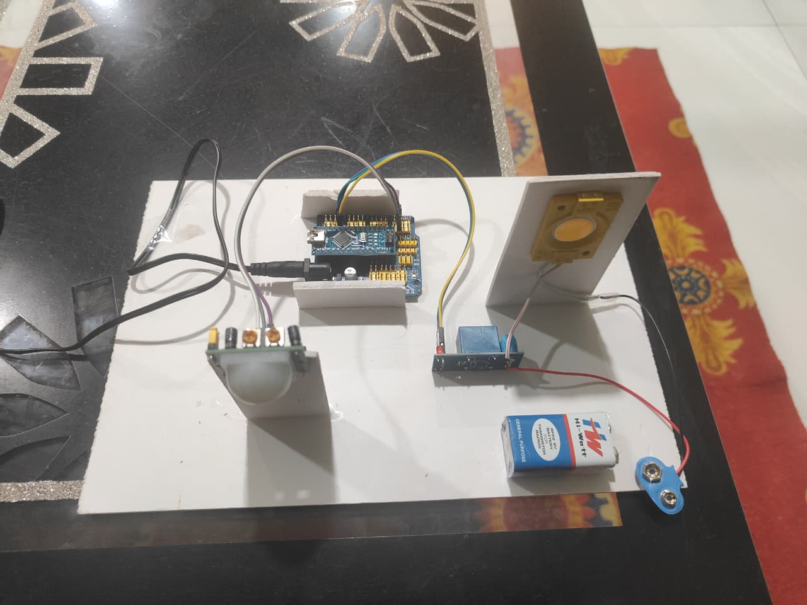
Fig 10.1: Energy Leak Detection


Fig 10.2: Energy Leak Detection

PAPER PUBLICATION
11.PAPER PUBLICATION

